Part 1 — Understanding Observability Stack
How each component works
- How to connect them
- How to create the exact panels you need
- How to use Grafana to observe metrics, logs, and traces together
This will be easy to follow and will be able to build my dashboards immediately.

✔ Prometheus
- Collects metrics from your microservices
- Scrapes /actuator/prometheus (Spring Boot) or /metrics (Micrometer/OpenTelemetry)
- Stores time-series metrics
- Grafana uses Prometheus as a data source to build dashboards

✔ Loki
- Stores application logs
- Works like “Prometheus for logs”
- Uses LogQL for querying (very powerful)
- Grafana uses Loki as log data source

✔ Tempo
- Stores distributed traces
- Receives spans from OpenTelemetry instrumentation
- Grafana’s “Explore → Trace” shows your spans

✔ Grafana
- Single UI for metrics + logs + traces
- Connects to all 3:
  - Prometheus → metrics panels
  - Loki → log panels
  - Tempo → trace panels
- Can link Logs → Traces and Metrics → Logs

⭐ Part 2 — How They Work Together
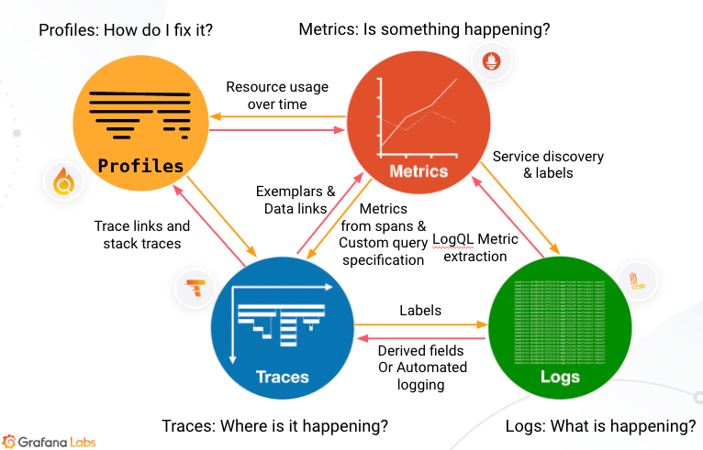
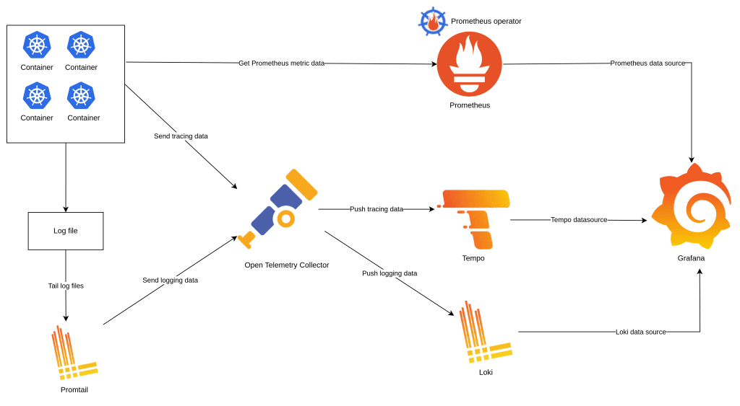

✔ The sample application sends:
- Metrics → Prometheus
- Logs → Loki (via Promtail/agent)
- Traces → Tempo (via OTEL exporter)

✔ Grafana retrieves:
- Dashboards from Prometheus
- Logs from Loki
- Traces from Tempo

✔ Grafana auto-links:
- From a log line → click View Trace
- From a trace → open service logs
- From metrics graph → click Explore → Logs or Trace
This gives us the full observability.

